Help - Custom Entity - Criar OData query com CDS tipo Custom Entity e classe abap cm Select
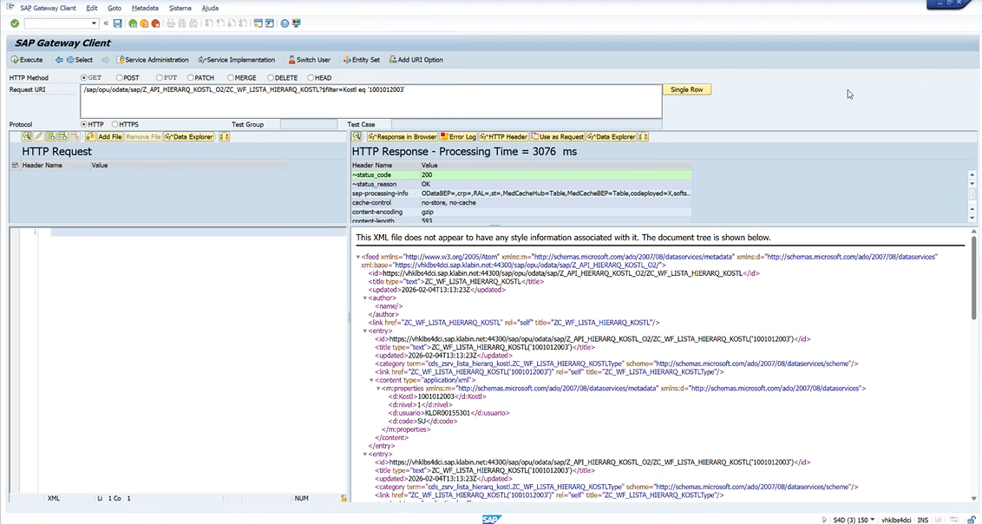

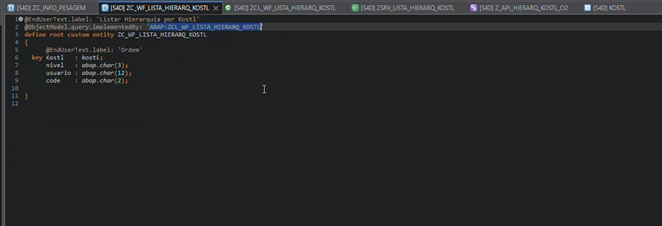

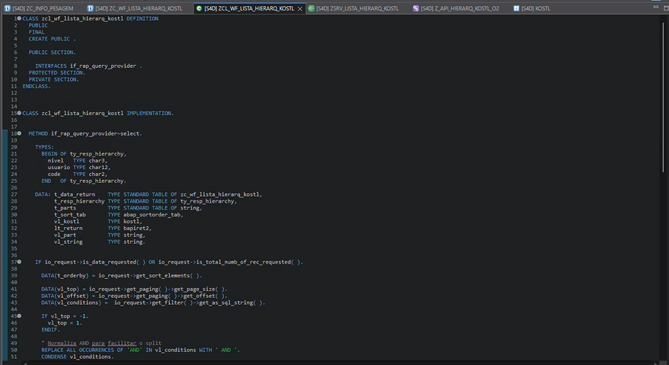

CLASS zcl_wf_lista_hierarq_kostl DEFINITION
PUBLIC
FINAL
CREATE PUBLIC .
PUBLIC SECTION.
INTERFACES if_rap_query_provider .
PROTECTED SECTION.
PRIVATE SECTION.
ENDCLASS.
CLASS ZCL_WF_LISTA_HIERARQ_KOSTL IMPLEMENTATION.
* <SIGNATURE>---------------------------------------------------------------------------------------+
* | Instance Public Method ZCL_WF_LISTA_HIERARQ_KOSTL->IF_RAP_QUERY_PROVIDER~SELECT
* +-------------------------------------------------------------------------------------------------+
* | [--->] IO_REQUEST TYPE REF TO IF_RAP_QUERY_REQUEST
* | [--->] IO_RESPONSE TYPE REF TO IF_RAP_QUERY_RESPONSE
* | [!CX!] CX_RAP_QUERY_PROV_NOT_IMPL
* | [!CX!] CX_RAP_QUERY_PROVIDER
* +--------------------------------------------------------------------------------------</SIGNATURE>
METHOD if_rap_query_provider~select.
TYPES:
BEGIN OF ty_resp_hierarchy,
nivel TYPE char3,
usuario TYPE char12,
code TYPE char2,
END OF ty_resp_hierarchy.
DATA: t_data_return TYPE STANDARD TABLE OF zc_wf_lista_hierarq_kostl,
t_resp_hierarchy TYPE STANDARD TABLE OF ty_resp_hierarchy,
t_parts TYPE STANDARD TABLE OF string,
t_sort_tab TYPE abap_sortorder_tab,
vl_kostl TYPE kostl,
lt_return TYPE bapiret2,
vl_part TYPE string,
vl_string TYPE string.
IF io_request->is_data_requested( ) OR io_request->is_total_numb_of_rec_requested( ).
DATA(t_orderby) = io_request->get_sort_elements( ).
DATA(vl_top) = io_request->get_paging( )->get_page_size( ).
DATA(vl_offset) = io_request->get_paging( )->get_offset( ).
DATA(vl_conditions) = io_request->get_filter( )->get_as_sql_string( ).
IF vl_top = -1.
vl_top = 1.
ENDIF.
" Normaliza AND para facilitar o split
REPLACE ALL OCCURRENCES OF 'AND' IN vl_conditions WITH ' AND '.
CONDENSE vl_conditions.
SPLIT vl_conditions AT ' AND ' INTO TABLE t_parts.
CLEAR vl_conditions.
LOOP AT t_parts INTO vl_part.
CONDENSE vl_part.
"BALTORESERVE
IF vl_part CP 'KOSTL = *'.
vl_kostl = vl_part+9. " pega depois do 'KOSTL = '
SHIFT vl_kostl LEFT DELETING LEADING `'`.
SHIFT vl_kostl RIGHT DELETING TRAILING `'`.
CONDENSE vl_kostl.
CONTINUE.
ENDIF.
IF vl_conditions IS INITIAL.
vl_conditions = vl_part.
ELSE.
vl_conditions = vl_conditions && ` AND ` && vl_part.
ENDIF.
ENDLOOP.
"Busca Hierarquia
zcl_wf_zportal_util=>selecionar_hierarq_por_kostl(
EXPORTING i_kostl = vl_kostl
IMPORTING e_return = lt_return
CHANGING c_resp_hierarchy = t_resp_hierarchy ).
IF t_resp_hierarchy IS NOT INITIAL.
t_data_return = VALUE #( FOR wa_data_return IN t_resp_hierarchy
( kostl = vl_kostl
code = wa_data_return-code
nivel = wa_data_return-nivel
usuario = wa_data_return-usuario ) ).
ENDIF.
IF io_request->is_data_requested( ).
* IF t_orderby IS INITIAL.
* t_sort_tab = VALUE #( ( name = 'KOSTL' ) ).
* ELSE.
* LOOP AT t_orderby ASSIGNING FIELD-SYMBOL(<fs_ordeby>).
* APPEND VALUE #( name = <fs_ordeby>-element_name
* descending = <fs_ordeby>-descending ) TO t_sort_tab.
* ENDLOOP.
* ENDIF.
*
* SORT t_data_return BY (t_sort_tab).
io_response->set_data( t_data_return ).
ENDIF.
IF io_request->is_total_numb_of_rec_requested( ).
io_response->set_total_number_of_records( lines( t_data_return ) ).
ENDIF.
ENDIF.
ENDMETHOD.
ENDCLASS.

